**TNBPAY Documentation**

**Version 0.1.0**

**Details –** This section provides the reader/user with an overview of the Plugin

TNBPAY is the fastest and easiest means by which you can start accepting The New Boston Coin as payment on your E-commerce store. TNBPAY provides a seamless gateway for your customers to be able to make payment for your goods and services using The New Boston Coin.

The system enables a full decentralization in payment as purchases made for your products are instantly credited into your wallet, eliminating the need for a middle man, delayed processes and promoting instant confirmation.

The plugin is specifically built to meet the WordPress Plugin Requirements without causing your theme to suffer or cause a lag on the speed of your website.

**Pros of using TNBPAY**

* Payments are credited **directly into your wallet**
* No need for signing/private key.
* No transaction fees (other than the network fee)
* Creates TNBC as a currency on installation in Woo-commerce
* Allows you to use TNBC as your default store currency
* Payment modal seamlessly integrate with your WordPress theme
* Quick Installation process
* Instant payment confirmation

**Installation –** This section details the step-by-step guide to installing **TNBPAY**

**Minimum Requirements**

* WordPress 4.7 or greater
* WooCommerce 3.3
* PHP 7

**Automatic Installation**

Automatic installation is the simplest method by which you can get the TNBPAY up and running on your site. WordPress seamlessly handles the file transfer and installation itself and all you will be required to do is to activate the plugin.

How to automatically install TNBPAY

* Visit [our Github repo](https://github.com/akandejaphet/TNBPay), the latest release is available for download under the readme as a zip file.
* Log in to your WordPress dashboard, navigate to the Plugins menu and click Add New

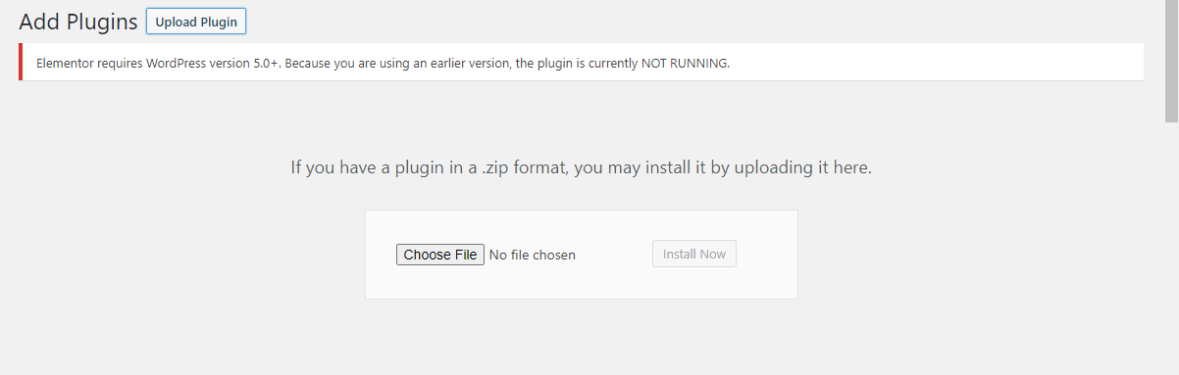

* Select the downloaded TNBPAY zip file and click on the install button on your dashboard

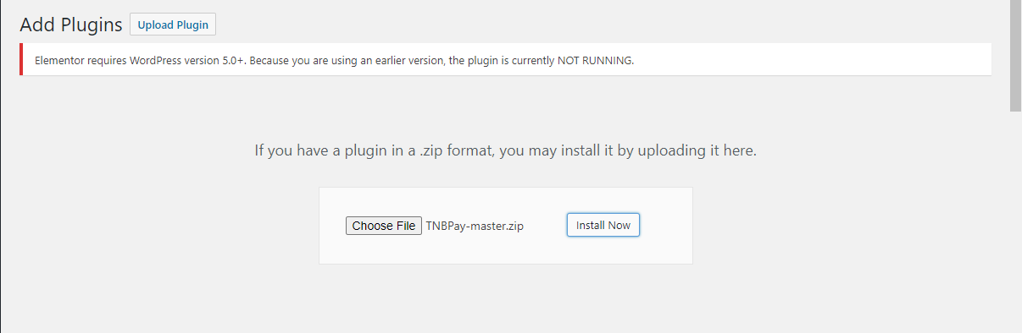

* Wait for the system to automatically install the plugin then click on activate

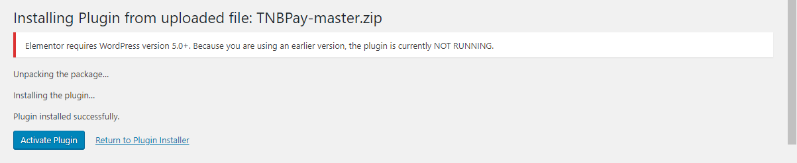

Once done with the process, your TNBPAY plugin will be fully installed, activated and ready for use.

**Manual Installation**

To manually install TNBPAY, you will need to download the TNBPAY zip file following the instruction above then upload it directly into your webserver using any FTP application of your choice. A detailed guide to do this has been provided [here](https://wordpress.org/support/article/managing-plugins/) by WordPress.

**Currency options**

TNBPAY currently supports US Dollars ($) and TNBC (TNB) Only. You can either choose to have your products listed in USD or TNBC. At Installation, the plugin automatically adds TNBC as a currency option. You can select this under woo-commerce settings.

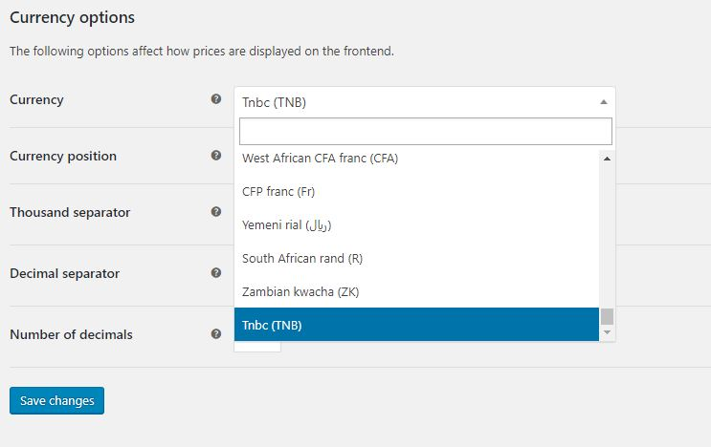

**WooCommerce Integration**

After Installing and activating the plugin. You will need to enable it as a payment method for WooCommerce. Go to WooCommerce settings > Payments.

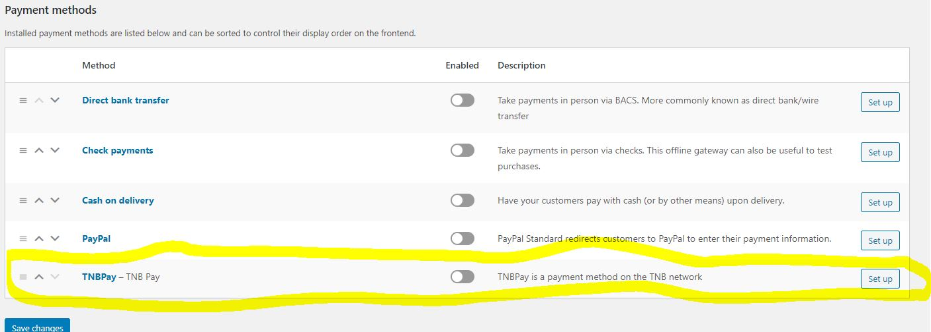

**Settings –** This section details the basic setting you will need to put in place to before deploying TNBPAY

To start processing payments using TNBPAY, you have to input your Wallet Address and the rate at which you are converting TNBC to USD.

How to setup your TNBPAY

* Go to your WooCommerce and click on the settings option
* Click on the Payment tab
* Click on setup on the TNBPAY column
* Input your wallet address and the standard exchange rate you want to peg the US Dollar to TNBC
* Click on save changes.

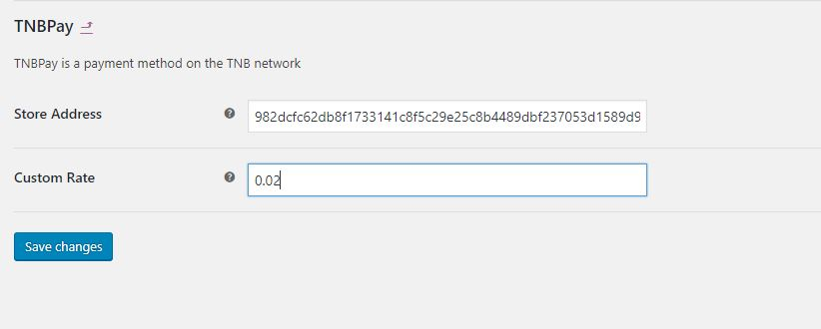

**Screenshots**

